ICT in the HPE CLASSROOM
With Rebecca Westwood
and website development ‘how to’
ictandtheclassroom.weebly.com
Prezi can be accessed here:
Engaging ict tools for the HPE classroom
http://prezi.com/kgvzlesqbquk/?utm_campaign=share&utm_medium=copy
Flipping the HPE classroom
http://prezi.com/saof37caf0nr/?utm_campaign=share&utm_medium=copy
Remember the rip analogy
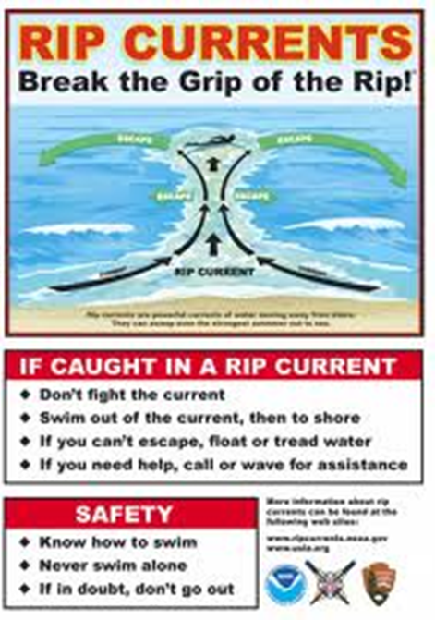
Don’t fight against technology – you will eventually drown

Let the students guide you – go with them and you will survive

ICT for analysis, assessing and improving performance in Physical Education
Currently how do you assess your students in PE practical classes?

How effective is it?

How do you justify to parents, the mark/grade you gave their child??

TOOLS TO USE IN YOUR CLASS TO ENGAGE

Video analysis – Performance criteria sheets + Feedback = enjoyment and learning
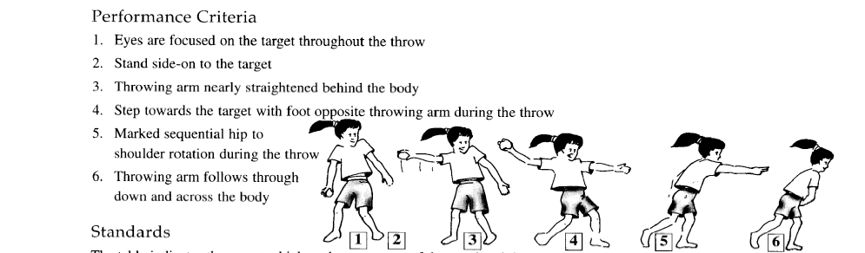
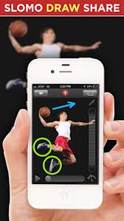
Apps that make video analysis EASY
Hudl Technique previously known as Ubersense
Coach my video
Coach's eye

Flipping the PE class using video analysis
At home watch game or professional perform the skill
Reduce the instructional time used in class
Get students moving and practicing the skill more.

Test development and marking made easy-- testmoz.com
Practise run
testmoz.com/176535
password: westwood

SEE PICTURES BELOW

- Easy test set up
- Records students results all marked for you
- Gives you the time they took on the test
- Gives you a summary of how many students answered each question correctly
- Class averages
- Also gives you an excel document with all their responses accessible for you to check if needed!
- Great to keep your records for minor tests.

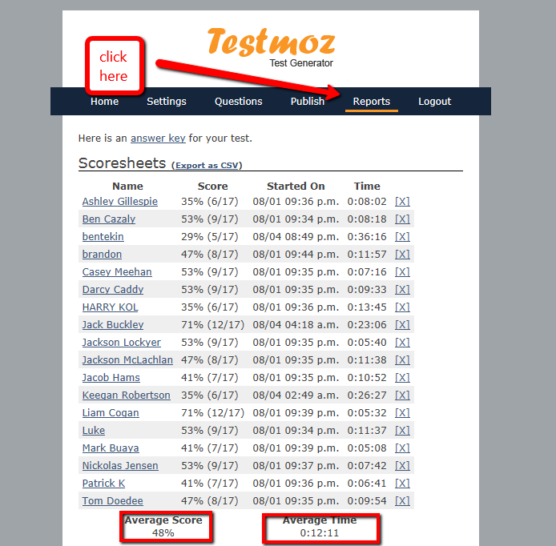
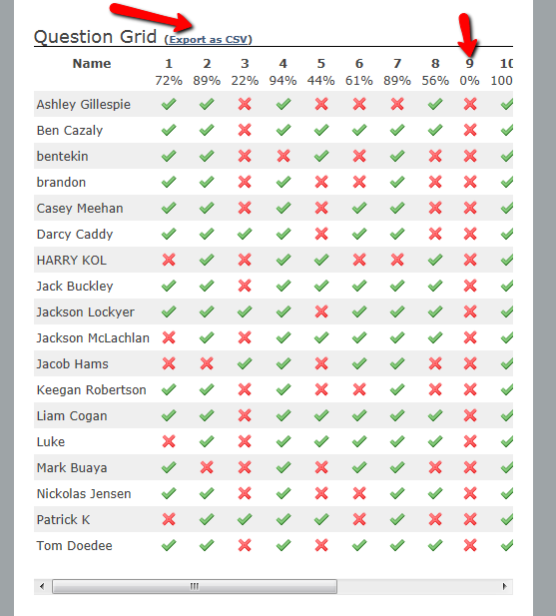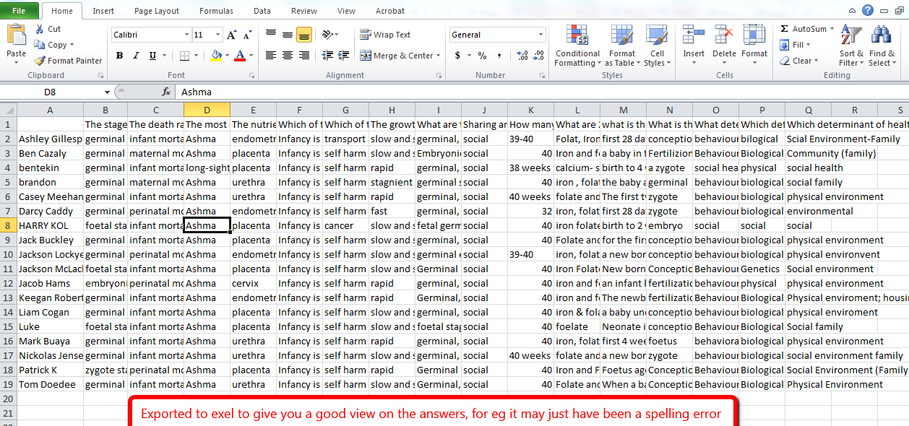

BLOG ENTRY and/or EXIT SLIPS
As students come into class I sometimes get them to fill out a 100-200 word ENTRY blog entry about a particular topic we are going to cover that class or a summary of what we covered in the previous class
- Gives me a great idea of prior knowledge
You can then ask students at the end of the class to fill in an EXIT blog and compare their knowledge and what they have learnt.

These ENRTY and EXIT blog strategy can work exceptionally well.
POWTOON.com
Make your class presentations more engaging and interesting for students

Prezi.com – Presentation format I used today
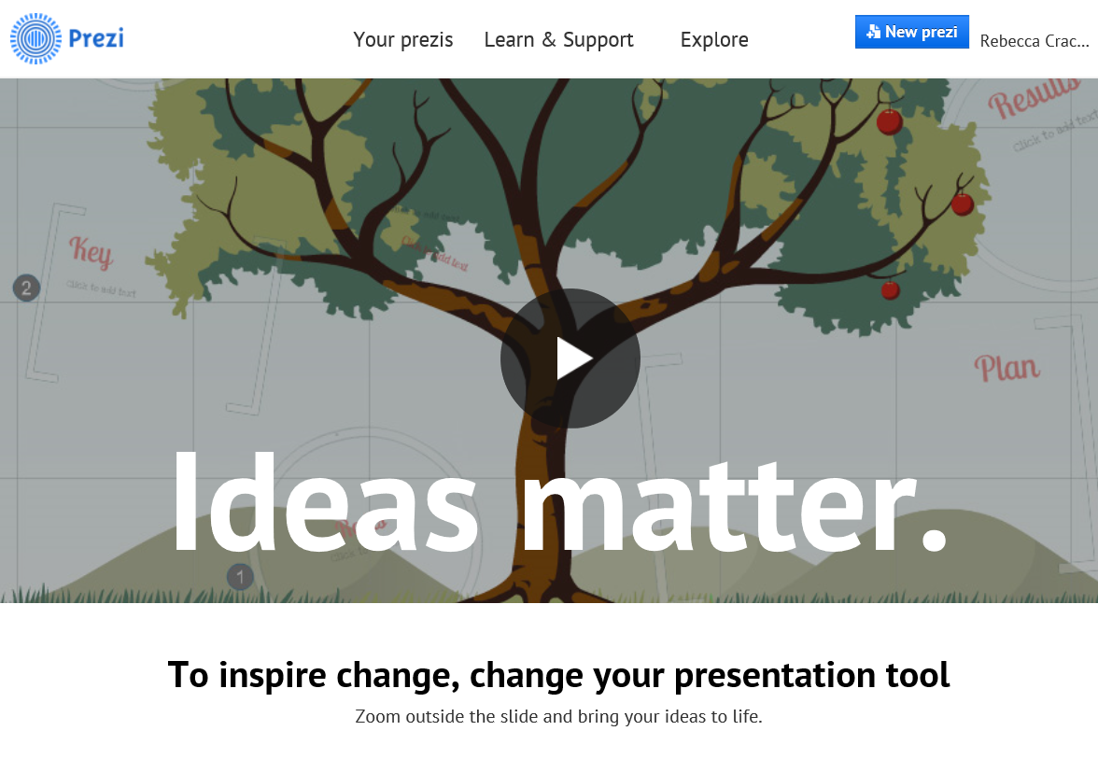
GoAnimate.com
Make your own class animations
Good to give kids the option of using this in assessment tasks

ANIMOTO.com
Creating great videos with ease
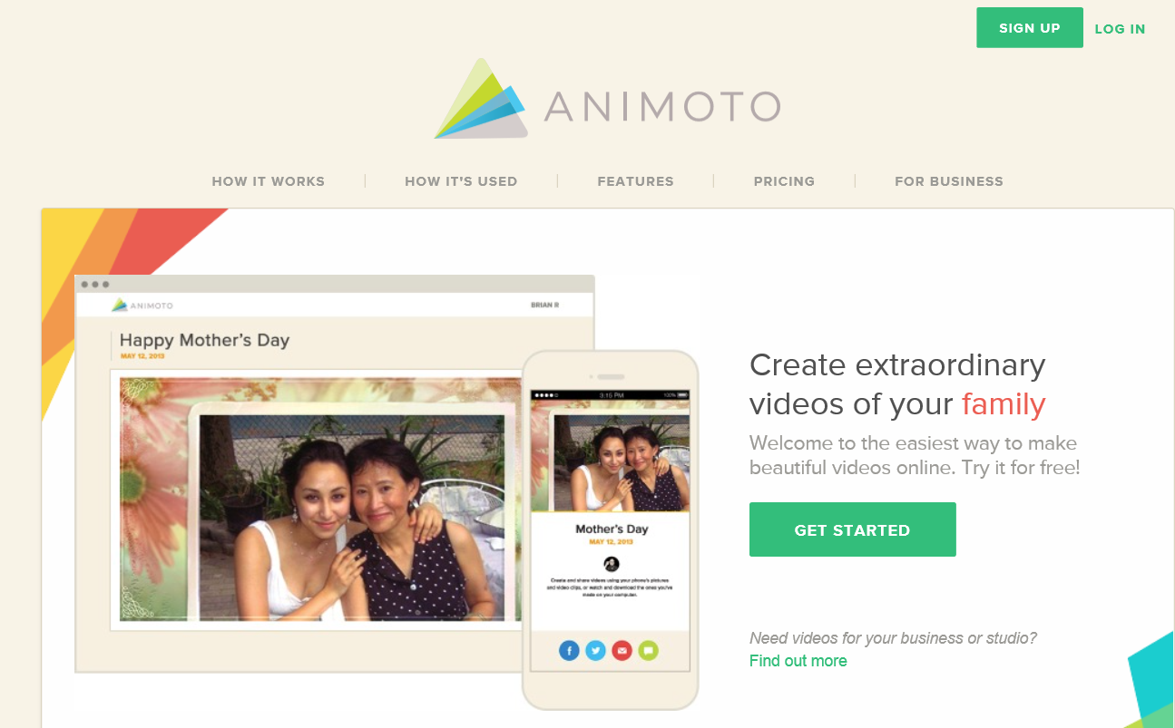

QR CODES
- Download QR reader on iPhone
- Go to QRstuff.com to create your own free QR codes.
Use this for fitness testing or circuit training
Great for sports that involve a lot of explanation/demos – such as gymnastics – scan below
Create your own QR codes quick and easy here
http://www.qrstuff.com/
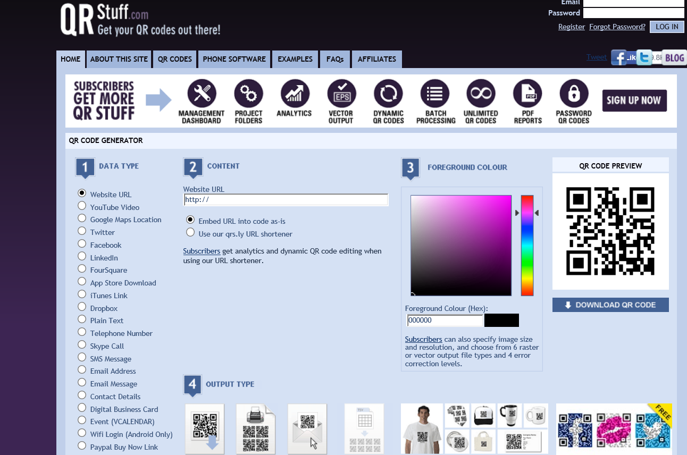
FLIPPING THE CLASSROOM
What is flipping? Innovative approach which allows direct/lecture type instruction happen at home and ‘homework’ /application activities can happen at school.
Why should we flip? Creativity, technology and fun. All children will flourish from this approach (stop, rewind re watch if they did not understand)

Ways to flip the classroom:
What you will need to make your own flipped videos:
- Video recorder or screen casting resource or
- educreations.com BEST! (ipad or mac/pc)
- Jing (short screencasts)
- show me app
- doceri app
- garage band or audacity to make your own podcasts

Or you can also use pre developed content:
- Youtube or other online clips (TEDed is fantastic)
- Podcasts on ITunes
- Reading material

Then what:
Then they can answer questions on reflective blogs or simply answer questions.

FLIPPING IN PHYSCIAL EDUCATION

- Get students to WATCH an instructional video at home to learn the basic skills, rules of a game or sport

- In class peers CAPTURE their technique

- SHOW THEM their technique or get them to analyse their technique at home for homework

- TEACH THEM the correct technique (and give feedback) in the next class or show them a video example of a professional completing the skill or game.

- Use the videos to help you ASSESS their ability to perform the skill and justify to parents the mark given.

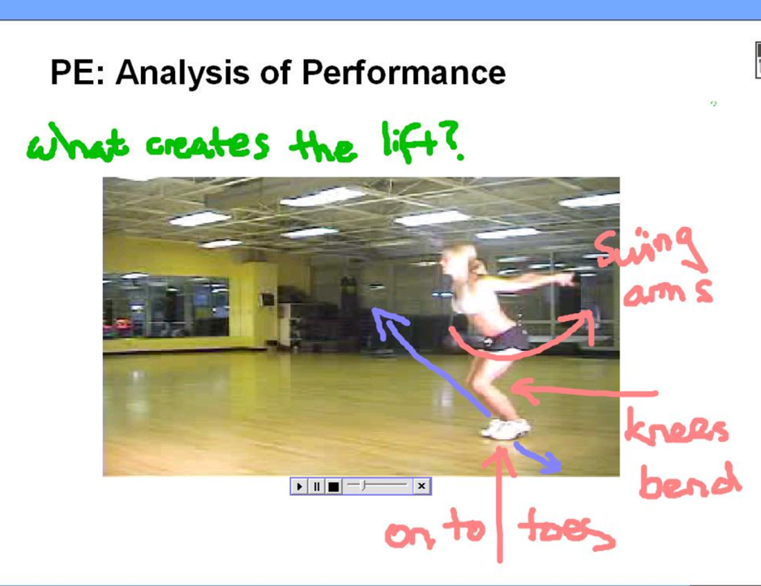

Blooms Pyramid – and the concept of flipping

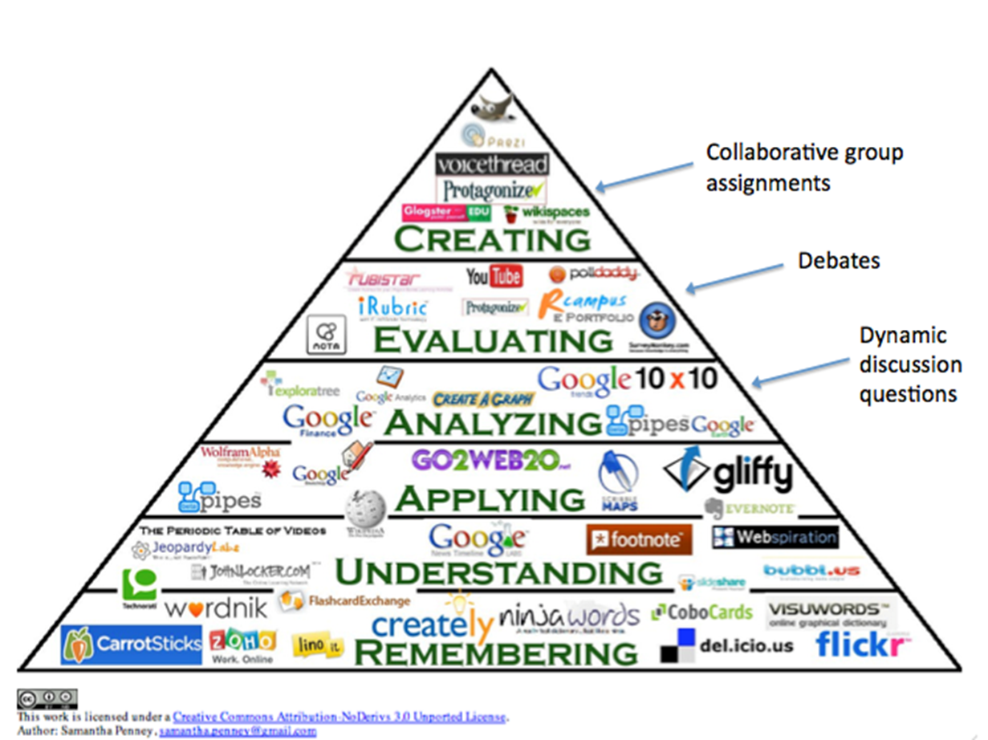

- Remembering and understanding levels can be done at home
- The higher levels of the pyramid need teacher support to guide the student through specific activities

WEEBLY.com

Website development made easy – check the website for instructions www.ictandtheclassroom.weebly.com

