Discovery Conference - Peak PhysEd 2015
ICT and PE
Rebecca Westwood
ictandtheclassroom.weebly.com

Go to ictandtheclassroom.weebly.com and click on the blog tab as shown below

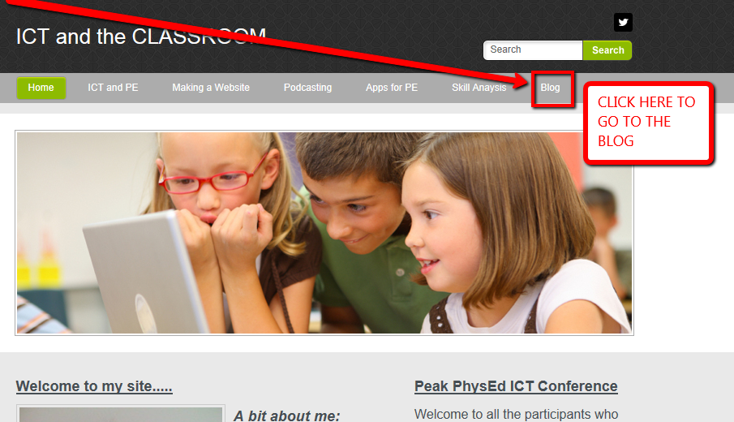

Video analysis
- UberSense (free)

Record
Record one or more techniques at a time, and organize them with the student's name and what skill they are completing. (by tagging it make it easy to find all of one students skills)

Analyze - Draw
Analyze skill performance for in-person feedback using slow-motion, drawing tools and compare side-by-side with pro videos.

Engage - Share
Record and send video lessons with voiceovers to your students and have them send you skill technique videos for review no matter where they are. (you could even set this as homework)

OTHER APPS THAT ARE SIMILAR
- Coach my video
- Coaches eye $

Presentation alternatives to power-point
- Prezi.com
- Powtoon.com
- Animoto.com
- Go Animate goanimate.com
- Haiku Deck – ipad app

Assessment tools
- Skill analysis apps
- Visual diary’s/reflections
- Google forms
- Testmoz.com (a great test development tool)
- Ipad grade book assessment tool IDOCEO2 (not free however it is fantastic)
- QR codes (app-QR reader or Qrafter) website to generate your own (www.qrstuff.com)
- Blogs to assess learning (entry and exit forms)
- Socrative (all devises – testing student understanding)

Other
- Weebly.com (a website development tool)
- Time motion ipad app to analyses athletes playing sport

Social Media
- Twitter for teacher PD
- Pinterest for teaching ideas
- Edmodo (an alternative to facebook)

SCAN THIS TO GET ACCESS TO THE PREZI

SCAN THIS TO GET ACCESS TO THE WEBSITE AND BLOG

FEEL FREE TO CONTACT ME WITH ANY QUESTIONS OR COMMENTS ABOUT TODAYS SESSION

My email address: rebeccac@sjc.vic.edu.au

